- INTRODUCTION
  - Data source: Pizzaz.com
  - 276 heterosexual couples (n=276)
  - Random couple assignments
  - Short speed date
- DESCRIPTIVE STATISTICS
  - Missing observations
    - 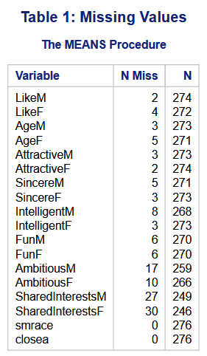
  - m/f split data
    - compare characteristics of interest for overlap
      - Overlap: attractive, sincere, intelligence, fun, ambitious
      - Men only: 2nd order attractive & Age
      - Women only: shared interests
  - Controls & summary categorical statistics
    - Same race couples: smrace = 1 (same) | smrace = 0 (different)
      - 121 couples matched for speed dating have the same race
      - 155 couples matched for speed dating do not have the same race
      - Correlation found near 0 values as pearson correlation coefficient, indicating there is no correlation between same race and likeness value
    - Age dif <= 2 years: closea = 1 (w.in 2 years) | closea = 0 (greater than 2 years)
      - 119 couples matched for speed dating are close in age
      - 157 couples matched for speed dating are not close in age
      - Correlation found near 0 values as pearson correlation coefficient, indicating there is no correlation between closeness in age and likeness value
- SELECTION OF THE MODELS AND TYPE OF ANALYSIS EMPLOYED
  - Split data for cross validation
    - 80:20 then check for n_{train} / k(#vars) >= 5
      - 80/11 = 7.27 yes greater than 5 obs per variable – good to use 80:20 split
        - 221 training (rounded bc cannot be partial obs)
        - 55 test
  - Check for higher order
    - Female (blend)
      - Age: single order not significant in blend
      - Attractive: first order significant in blend. No others signif
      - Sincere: first order sig. in blend. No others
      - Intelligence: first order only
      - Fun: first order only
      - Ambitiousness: first order only
      - Shared interest: first order only
    - Men (blend)
      - Age: single order only
      - Attractive: 1st and 2nd order
        - Center attractivem (obs – mean) then create squared val with centered attractivem to prevent collinearity between 1st and 2nd order
      - Sincere: first order only
      - Intelligence: first order only
      - Fun: 1st order only
      - Ambitiousness: 1st order only
      - Shared interests: not significant at all
  - Write out pairwise & up
  - Develop models:
    - y = attractiveness, sincerity, intelligence, fun, ambitiousness, and shared interest
    - K = 6
    - Females:
    - Males: (likem squared due to normality test results)
      - Initial model
        - Likem = attractive_{(centered)}x + sincerity x + (fun * shared interests) x + (attractive_{(centered)})² x + intercept
        - LikeM = 0.44620x + 0.19745x + 0.03201x - 0.05965x + 3.96622
        - 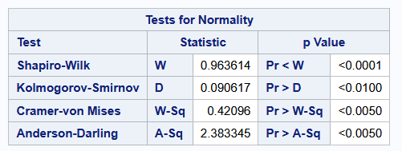
      - Modified model
        - Likem_2 = fun + attr_sinc + attr_sint + intercept
        - Likem_2 = 1.87367x + 0.39251x + 0.41240x - 2.73330
- DIAGNOSTICS
  - Residual evaluation
    - Males (initial)
      - Cook’s distance = 0 outliers
      - Leverage = 27 outliers
      - Jackknife = 15 outliers
      - Boxplot = many outliers within 1.5 quartiles (approx. 8?)
        - Semi normal distribution
        - Qq plot shows semi normality
          - 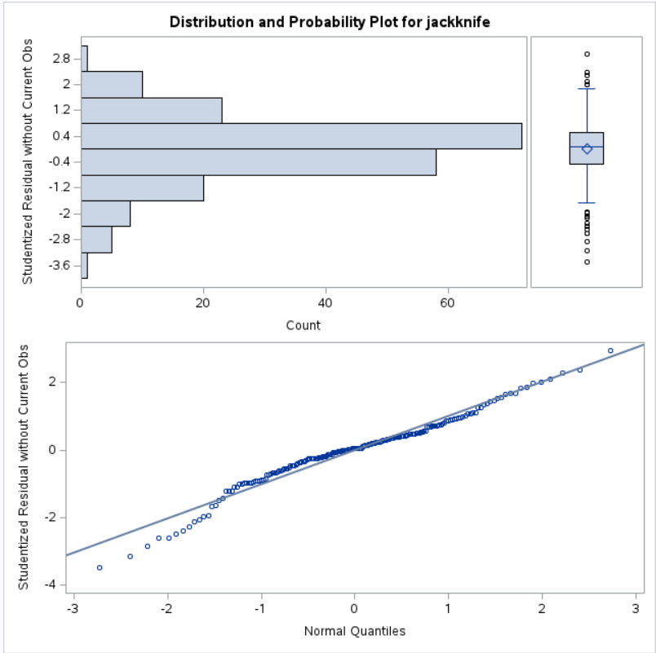
        - Normality tests all show <0.05 -> reject H0 (H0 = normal distribution). Rejecting H0 indicates not normal distribution
          - 
    - Male (corrected)
      - Jackknife = 13 (net -2 outliers)
      - Leverage = 10 (net -17 outliers)
      - Cooks distance = 0 outliers
      - Boxplot – increased normality with reduced outliers & improved fit on q-q plot
        - Outliers ~ approx. 6
        - 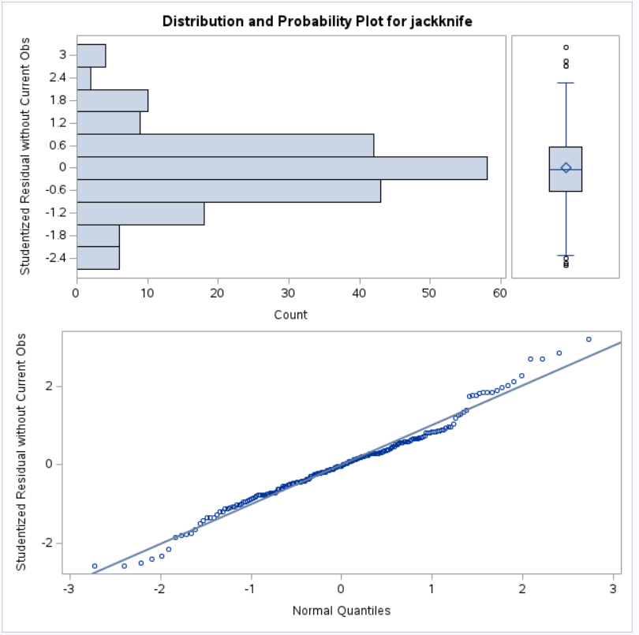
      - Normality tests
        - 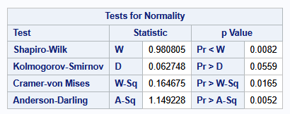
          - Kolmogorov-smirnov test lets you reject H0 and go with normal dist.
  - Cross validation on test data
    - Calculate shrinkage (R²_{TRAINING} – R²_{TEST})
      - <0.10 RELIABLE
      - >0.90 VERY UNRELIABLE
- SUMMARY OF FINDINGS

APPENDIX A:

